|  |
| --- |
|  |
|  |



#### Introduction to IT

#### Assignment 3

#### Project plan

#### Group #13

[This Photo](http://wccftech.com/most-exciting-pc-gaming-tech-coming-in-2016/) by Unknown Author is licensed under [CC BY-SA-NC](https://creativecommons.org/licenses/by-nc-sa/3.0/)

Contents

Introduction 3

Team profile 3

Group Assignment Tools 3

Project Description 6

Skills and Jobs 21

Group Reflection 22

Conclusion 26

References 27

# 

# Introduction

This report covers the project created by Group #13 to fulfil the requirements for assignment 3 for the unit Introduction to Information Technology. The report sections detail all facets of the project, including an analysis of each stage of the project, why the project was chosen, planning, execution and reflection. The project aims to address the issue of water resource management using innovation and open source technologies to provide a solution for irrigating gardens efficiently and sustainably. The underpinning solution provides an irrigation system that is optimised by autonomously monitoring environmental conditions, thereby saving water resources.

# Team profile

Our team “Group 13” comprises the following members:

* Ben Tomlinson - s3390149
* Grant Dawson - s3812606
* Michael Reyland – s3293934
* Sukhman Singh - s3820261
* Joseph French – s3754586

The Group 13 team profile can be found at:

<https://benjamin-j-tomlinson.github.io/IITA3_Group_Profile/index.html>

and contains the following information:

* Personal information for each team member
* Summary of group performance in Assignment 2 and processes for Assignment 3
* Individual career plans and comparison summary
* Link to individual Assignment 1 websites
* Existing Assignment 2 content

# Group Assignment Tools

Various online tools were used to administer group Assignments 3 and 5. GitHub was used for version control of the team profile website and the Arduino programming. A link to the website repository is <https://github.com/Benjamin-j-tomlinson/IITA3_Group_Profile> and the Arduino sketch repository is <https://github.com/grantsdawson/IIT_A3>.

RMIT Canvas and Microsoft Teams were both used for communication between team members, however once set up, Microsoft Teams became the prime mode of communication. Both Canvas and Microsoft Teams retain all the chat history, providing an audit trail of group formation, discussions and decisions made along the way. Our Microsoft Teams site “Intro to IT Group 13” can be found [here](https://teams.microsoft.com/l/team/19%3a7c1d9347f00a4a80a1aeeedc816a41cc%40thread.skype/conversations?groupId=1e884489-ae33-4c06-b4ca-3822e71c8b71&tenantId=d1323671-cdbe-4417-b4d4-bdb24b51316b) for review (you will need to request access first via the link) or you can use this code – kbsqkfw - so you can view without requesting access.

Version control for this report and its contributing artefacts was also managed via Microsoft Teams (there is a backup of our main files in the Arduino sketch Github repository in case there are access issues for the lecturer marking this assignment, however the best example of our work is seen by accessing our Microsoft Teams site). We broke the assignment specification into its individual parts in a spreadsheet task tracker so each team member could assign themselves to each section. As each section was completed, the spreadsheet was updated with status and comments. As SharePoint is the document repository behind Microsoft Teams, there is a full audit trail detailing the history of each document.

Overall, the combination of tools provides a detailed and accurate audit trail of Group 13’s work to complete Assignment 3 and 5. Microsoft Teams can provide statistics on number of users, messages and apps used over time which provides for some oversight on the patterns of communication over the duration of the assignment. Microsoft Teams enables the use of MS Planner as a basic agile/scrum type task board/Kanban board. Our group used this app to break the prototype and final product into core elements and features. The app can also be viewed on its website and exported to excel, from where it can be manipulated further in excel or other tools such as MS Project.

###### Figure 1 - Example statistics 28 days to 28th Oct 2019 (log in to Teams site for current statistics)

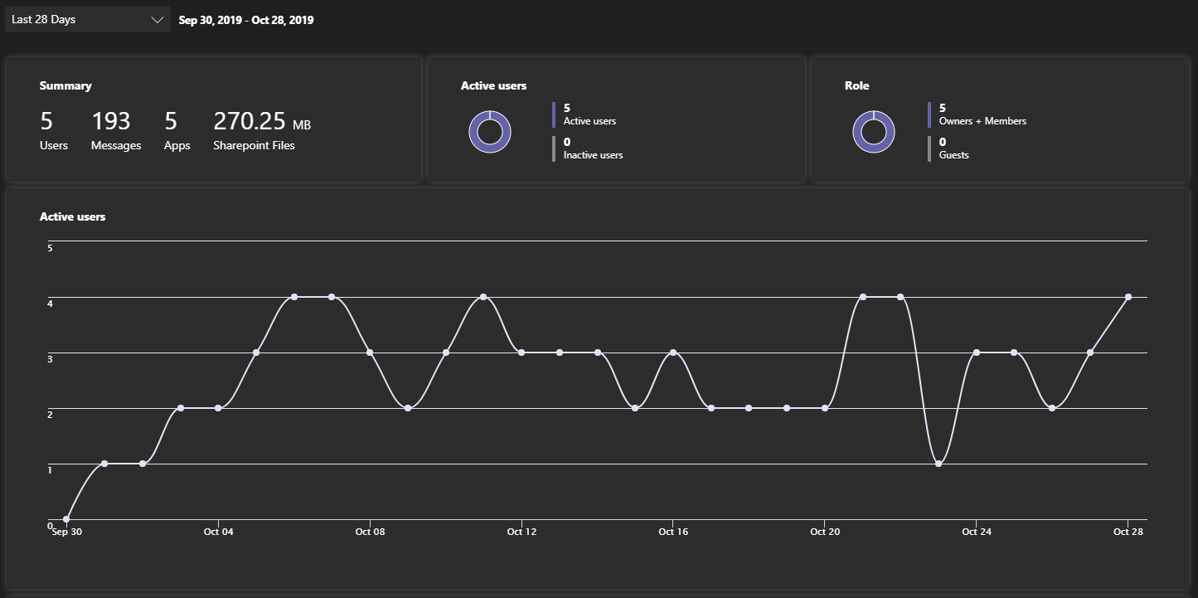

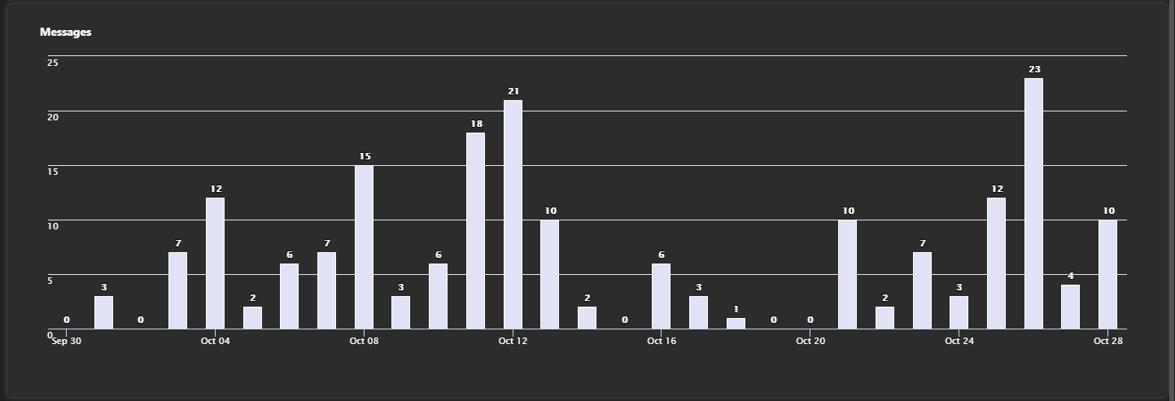

*Figure 2 - Example of using MS Planner in Teams (log in to Teams site for current status)*

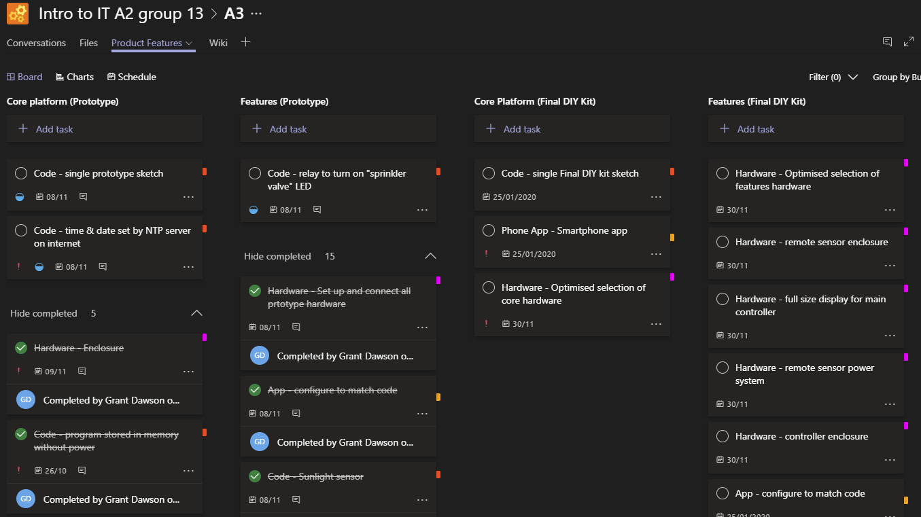

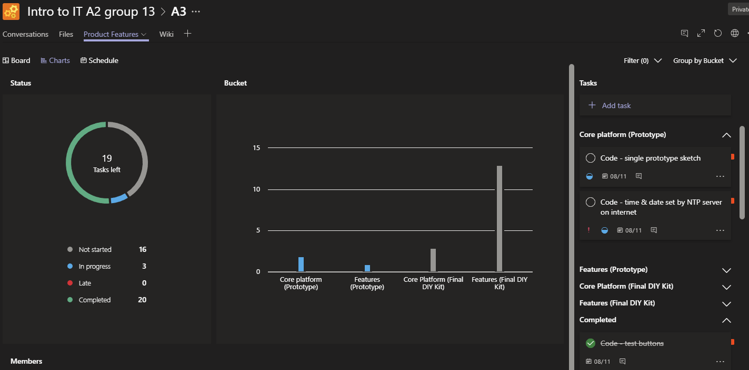

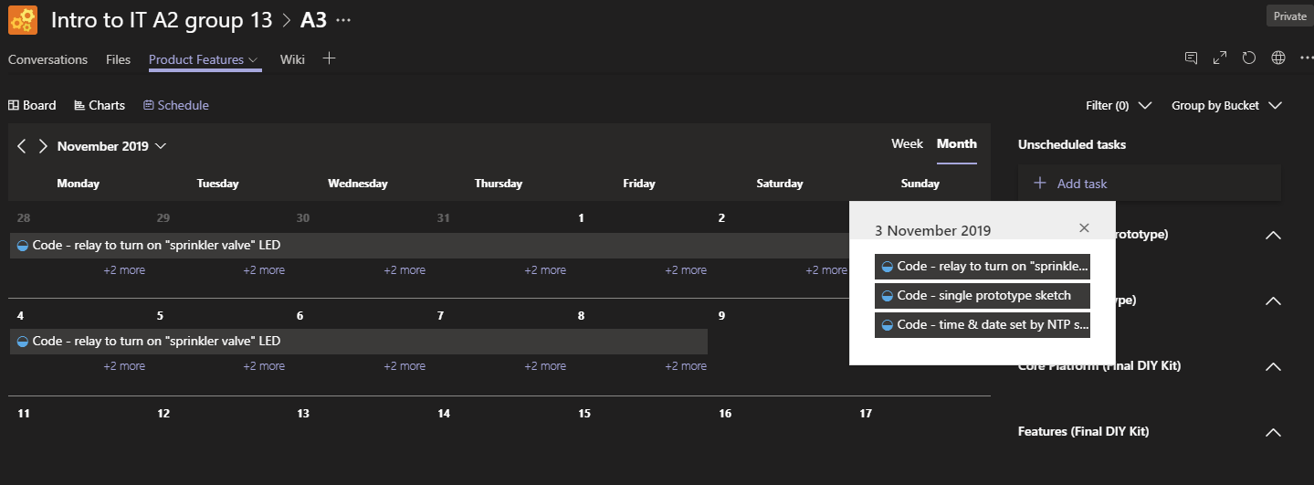

# Project Description

### Overview

#### Topic

Our project entails the design, build and sale of a low cost, do-it-yourself (DIY) reticulation controller kit that also provides sensors to measure weather conditions and can communicate with a smart phone application. Along with the kit itself, the project aims to deliver several associated deliverables, such as sample code in a public Github repository and a series of YouTube instructional videos. A subsection of the project will be completed and documented during the Assignment 3 and 5 period (as detailed further in this report).

The DIY kit is aimed at a variety of markets, such as:

* Countries or regions where cost is a barrier to implementing technology to improve resource usage in food production
* IT and gardening hobbyists
* a great gift idea for teens, as parents will identify with the benefits of both getting outside growing things, along with providing education in a broad range of IT skills

Expected outcomes of the project include providing group members with:

* Experience on a real-world project that reflects their passions, interests and skills
* A chance to complete work that aligns with their career plans and
* An opportunity to think in an innovative and entrepreneurial manner

#### Motivation

Our group motivation for this project stems from a desire to improve our technical and business skills, plus an interest in solving real life issues with IT.

From a technical point of view, this project enables the group to expand our skills in hardware (such as Arduino microcontrollers, analogue and digital sensors, LCD screens and relays) and software (coding for Arduino and configuring IoT Cloud services and iOS IoT apps). The project also provides the group a chance to exercise innovative and entrepreneurial thinking on the business side, such as how the DIY kit could be successfully marketed and how it can be made both low cost yet profitable.

The project is important as it aims to bring an enhanced technological toolset to gardeners to better manage their water resources for a lower financial outlay than commercially available alternatives. As Ren et al. (2018) state, agriculture (food) places one of the biggest pressures on world-wide water supplies. This would be especially useful in developing nations where cost is a barrier to implementing technology and helping the environment.

One of the biggest IT trends of recent years is the expansion of the internet of things (IoT). This project provides the group with great exposure to IoT, from the hardware and software used through to testing and marketing the final product. If marketed properly this product could also promote older generations to improve their technological knowledge by following the set of provided instructions to complete the DIY system. Technology adoption with older generations is an increasing problem for society given the ageing population (Macedo 2017), therefore products like this that can help improve technology literacy, could help to increase involvement by older adults. Because this project is so broad, it is a good example to share with future employers as they would see a wide range of IT skills being used.

#### Landscape

While we didn’t find any DIY kits like ours for sale on the internet, there are commercially available models with many of the same features. The [Orbit B-Hyve Tap Timer](https://www.bunnings.com.au/orbit-b-hyve-tap-timer-with-wi-fi-hub_p0081357) enables programming and operation from a smart phone app and also adjusts it’s water time depending on weather conditions obtained via the internet. The [Orbit B-Hyve Smart Timer](https://store.orbitonline.com/store/products/b-hyve-12-station-smart-wi-fi-sprinkler-timer/) is another more traditional reticulation controller, however it has the same smart features as the tap timer. None of the commercially available systems we found allowed the addition of any weather station sensors (i.e. temperature or rain sensors).

[Open Sprinkler](https://opensprinkler.com/) is one system that is very similar to our project idea. Open Sprinkler is based on Arduino or Raspberry Pi and can have weather sensors attached, but the difference is that the hardware has been developed into a single physical unit that needs to be purchased rather than assembled from widely available parts.

Our project provides a base offering with instructions that can be followed with a beginner level of IoT experience, or it could be fully customised by someone with more intermediate to advanced skills. Because we sell a kit rather than a piece of hardware, we will save money on research and development to bring the kit to market, plus on going we won’t have the cost overheads of manufacturing and stocking the hardware, we can get the kit shipped direct from a wholesaler to the customer upon ordering.

### Detailed Description

#### Aims

Our aim for the project as a group is to design and create a working DIY (Do It Yourself), Arduino micro irrigation controller prototype. In addition to the device functionality, it must be practical and viable for product marketability. The device must fulfil the requirements of the design and overall concept while adhering to economical restrictions. For functionality the device must analyse environmental conditions and adjust watering frequencies to reduce water usage and wastage.

Long term goals:

* Working prototype – we will produce a minimum viable product (MVP). This will serve as a basis for a marketable product as it gets developed. In order to develop the product further a protype is necessary to test and modify designs for the device.
* Design for end-product including research and development. This is a long-term goal as product development can take a long time. As consumer needs change and the demand for newer technologies the plan for further development is critical for the product to be successful.
* Documentation – drafts will be existing links and resources on the web and those made by the team. User documentation will help the consumer through various guides and resources for setting up the product and for support.
  + Documentation for the protype, models and specifications are also necessary to keep a track of previous developments to further improve the product.
* Brief marketing plan for final product for brand and product exposure. A plan is also necessary through analysing market data and trends. Additionally, analysis will provide user needs information and the initial target demographic.

Short term goals:

* Develop a plan and outline of the project by breaking down the project into manageable steps. By thoroughly planning and outlining each stage of the project will ensure each aspect is covered during the development of the project. Moreover, this will indicate any issues that may arise during the development of the project and what can be done to rectify them.
* Assembly of the product and its components is the practical aspect of the project and the prototype. This is critical as testing and implementation involves physical hardware which cannot be done without assembled components. Also, without a physical implementation of the project would make it difficult to market a product, seek investment or find out if a prototype is viable.
* Integration of system software for the device to function is necessary as the components need to be programmed for it to function. The software also needs to be developed for the various modules to communicate between each other, the Arduino board and external devices such as a router.

Contingencies:

* If some components were not able to be connected from lack of experience and time constraints, other components can be connected to device. As this device is just a prototype, basic functionality is required but more complex features can be added with each version. As this can be done, a marketable DIY kit can eventuate after the product has been developed from this prototype.

#### Plans and progress

Our project is, as previously described in Assignment 2 and earlier int his report, centred on the design, build and sale of a low cost, do-it-yourself (DIY) reticulation controller kit. Being “open source” in a fashion, the kit will use globally available hardware components, the code plus instructions for the kit will be available to the public and software tools used to program the hardware is currently freeware. A series of instructional videos will be available on YouTube.

During the 5-week assignment period for Assignments 3 and 5 (Phase 1), Group 13 planned the whole project from start to finish. We then segmented the project work and detailed what we would complete during Phase 1 versus the additional 10 weeks after the assignment finished (Phase 2). Phase 1 was planned with both a task list in excel and the Microsoft Planner app available in Microsoft teams, where Phase 2 is only reflected in the Microsoft planner app. In addition, the work for both Phases has been summarised in tabular form in the Timeframe section of this report. Rather than repeat the task detail in this section, we will refer to the detail in Microsoft Teams and summarise, while provide commentary addressing this assignment question.

The planned tasks for Phase 1 can be summarised as:

* Plan the project (break the work into tasks, sequence the tasks)
* Document and prioritise the DIY kit features, separating into Prototype and Final DIY Kit
* Prototype hardware and software:
  + Produce a minimum viable product to prove we can make the intent of the design work (i.e. some sort of phone app reading sensor data and controlling some device/s over the internet)
* Complete the Assignment 3 report and website
* Complete the Assignment 5 Video Presentation

Phase 2 will take the Phase 1 prototype and any lessons learned and then produce a final product plus take the product to market.

Our actual progress versus planned for the assignment period was quite close. All tasks on the excel task list were completed and all but 2 of 23 prototype tasks in Microsoft Planner were completed.

*Figure 3 – Microsoft Planner app showing complete and in progress Prototype tasks*

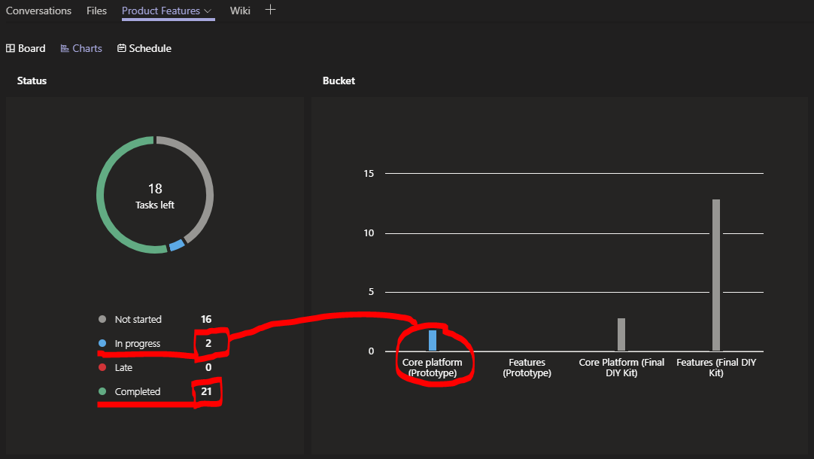

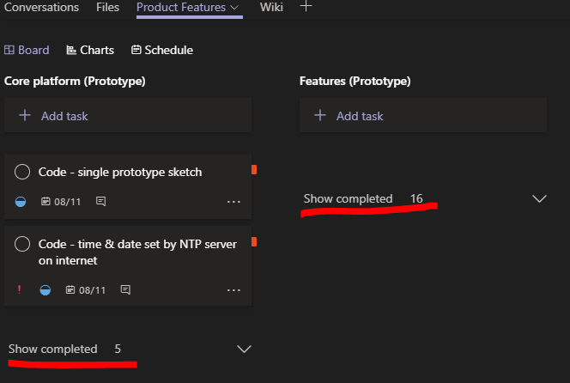

In addition to tracking progress in the excel task list and Microsoft Planner, we utilised the wiki function in Microsoft Teams to document the process of completing each prototype task. The wiki app allows you to build a simple wiki with section headings so you can track tasks or stages with notes, links and images. Conversations (chats) can be instigated for each section, making this a very powerful collaborative tool. We encourage the lecturer marking this assignment to login to the Microsoft Teams site to see the full extent of what we documented and how we used Microsoft Teams (link and instructions in the Group Tools section at the start of this assignment). Our Microsoft Teams site would be instrumental in any effective handover of this project to a new team, or when introducing new individuals to the team. We also produced a schematic for one of the tests, but for the rest just described the connections in the wiki in the interests of time. Design schematics and As-built schematics will be part of the final project deliverables.

*Figure 4 – Microsoft Teams Wiki documenting progress*

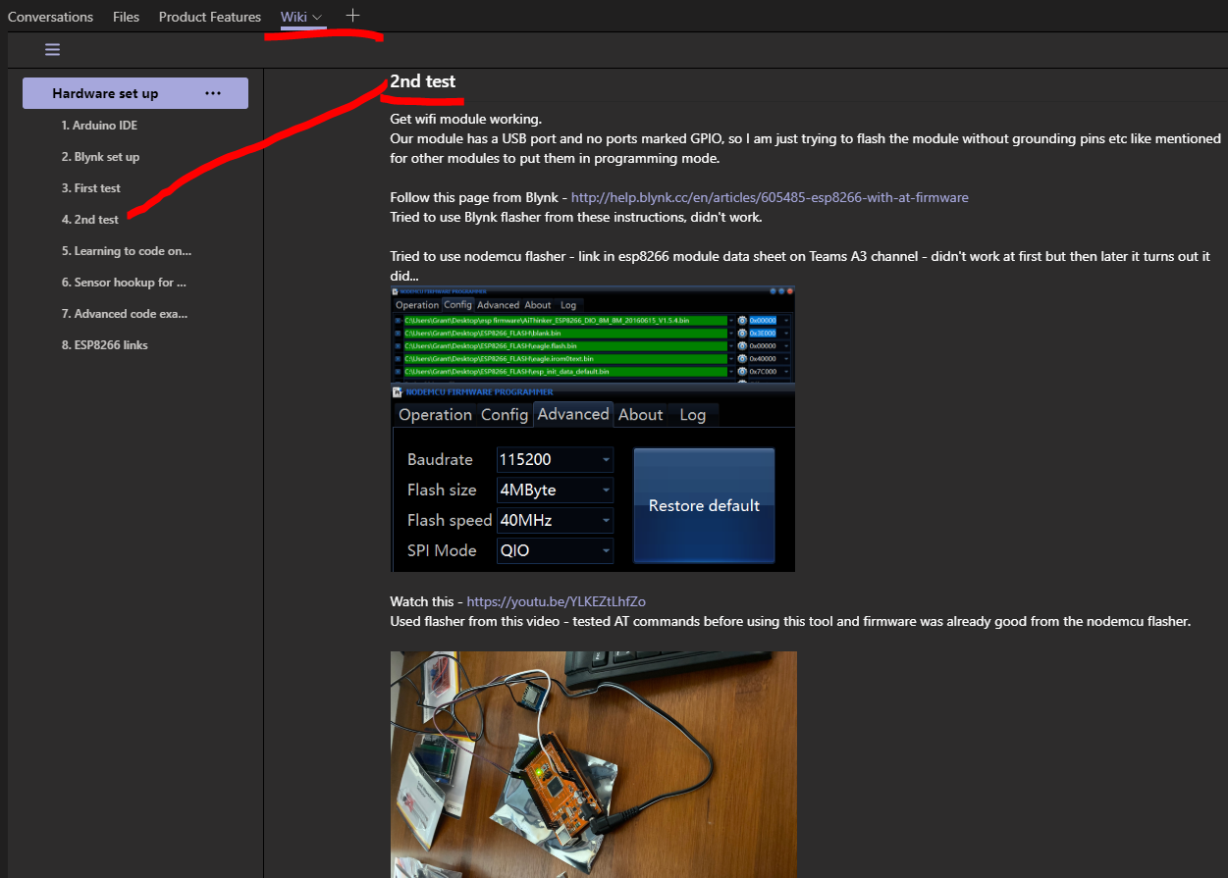

*Figure 5 – First basic schematic for test connection of prototype sensors*

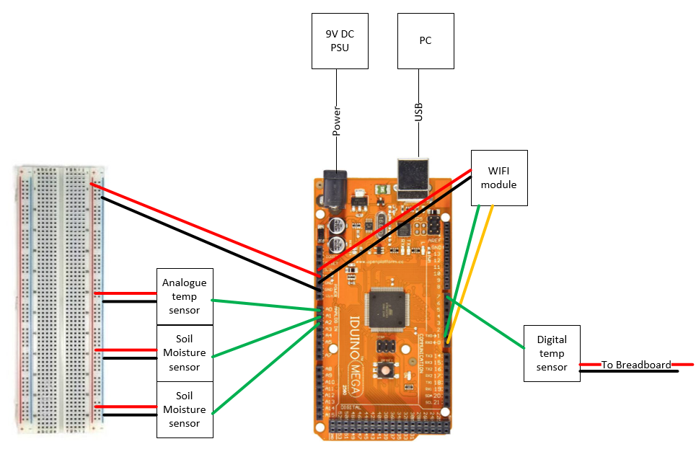

We tracked issues in an Excel spreadsheet Issues Register but really only hit one dead end through Phase 1 and that was related to the hardware chosen for the prototype. While not a true dead end (as apparently the hardware chosen can work), we unknowingly picked the most difficult combination of devices to use for our project. We selected an ESP8266 module to use as a WIFI modem for the Arduino Mega which appeared fine at the beginning, but as we dug deeper into how to realise our vision, we found that every tutorial detailing the use of an ESP8266 for connection of an Arduino to the internet says it’s the most complex option and not for beginners. Working through the prototype we now definitely believe them! We didn’t pick that up in our initial research before purchasing the hardware, only once we started to get into programming it. We were unable to connect to an NTP server for time syncing and didn’t get time to complete that feature during Phase 1. Moving forward in the plan we expect we need to revisit the Arduino board we use and get something with WIFI integrated so the Arduino libraries and WIFI commands are simpler. Even though this is a DIY kit, it, doesn’t make sense to continue with this difficult option if there are simpler options.

The other prototype feature left incomplete at the end of Phase 1 is to produce one single Arduino sketch (program). The learning curve proved too steep for the timeframe available and while each feature was proved one at a time or a few at a time in a single sketch, many code examples included the *delay()* function which is incompatible with the Blynk iPhone app we selected for the DIY kit. To learn how to achieve the same end without the delay() function was another level that Grant couldn’t get to in the 5 weeks available.

One of the major decisions we made during Phase 1 was the format and content for our Assignment 5 video presentation. As our project is to create a DIY kit, we decided to produce a draft of the first video in our instruction series, an introduction to the kit including an overview of what the kit will do and what it consists of. Given we are only 5 weeks into our project we don’t have a final product to film, so we used stock images from the internet to try and produce a good representation of what the final video would look like.

#### Roles

Rolling into Assignment 3 we first thought that we would be able to continue without defined roles, as it worked well for the group in Assignment 2. We soon realised that this assignment would require some different structure, as we were developing a project idea that required hardware to test the software programming. We only had one set of hardware, so the hardware set up and programming needed to be one person’s role. That person also had to spend time documenting and explaining what they were doing so that the others could use that as guidance for other assignment tasks such as the report and video presentation.

To spread the assignment task load we did segment website development and video filming/editing out as standalone tasks, so along with the project design/build/program work they could be described as three discrete roles that were created. The report content and the video script were largely a combined team effort.

#### Scope and limits

The key deliverable of this project within the given timeframe is the production of a functioning prototype irrigation controller that is configured using already existing software. This prototype will be configured to respond to a range of inputs from sensors including rain, temperature and humidity, sunlight and soil moisture levels.

To effectively deliver the product and associated technology, the below elements are defined as in scope or out of scope. It is important to note that the out of scope elements are defined as such, largely due to the available timeframe. To deliver the final marketable product the out of scope elements would need to be completed.

In scope:

* Fully functioning prototype system
  + Open source Arduino microcontroller configured to respond to triggers from rain, sunlight, soil, temperature and humidity sensors
  + Configured using the Blynk application (existing software) with two-way communication connected through the Wi-Fi.
* High level design for final product
* Detailed design (schematics) for each final product feature actually developed and built
* Information detailing each feature of the prototype unit
* High level resource plan and schedule for product development post assignment
* Draft marketing plan including estimated costings (RRP)

Out of scope:

* Optimising hardware and software for performance, efficiency or cost including the recommendations on the most suitable hardware and software components for a final product.
* Custom written phone app
* Connectivity solutions for remote locations where Wi-Fi use is not viable
* Backend cloud infrastructure
* Final marketable product
* Final design

#### Tools and Technologies

Various hardware, software and physical tools were required for this project, namely:

* Hardware – we have listed what we procured or sourced for this project:
  + Iduino Mega 2560 R3 (Arduino clone)
  + Iduino 37 in 1 Sensor kit (ST1065)
  + Iduino Starter kit (KTS016)
  + esp8266 wifi XC3802 (Jaycar)
  + LCD controller XC4454 (Jaycar)
  + rain sensor XC4603 (Jaycar)
  + Duratech Breadboard jumper leads - mixed type pack (Jaycar)
  + Power tech Plus MP-3310 multi-voltage Switchmode power supply (Jaycar)
  + iPhone 11
  + Desktop PC
* Software – no licensing was purchased specifically for the project, Windows and Office products are licensed but were already available to us, everything else was free to use:
  + Arduino IDE desktop app v1.8.9
  + Current Windows 10 operating system
  + Git Bash
  + Office 365 suite
  + Microsoft Visio 2016
  + Blynk iOS app
  + Sony Vegas Pro v17 (for Assignment 5 video)
  + Adobe Premier Pro (for Assignment 5 video)
* Tools:
  + Soldering iron & solder
  + Pliers
  + wire clippers
  + wire stripper
* Other:
  + Github website
  + Internet connection

None of the group had prior experience with programming Arduino boards or the Blynk app, however Grant had prior experience with soldering and cabling so was able to make the few leads and minor circuits required. A breadboard was used to limit the physical cabling and soldering required to prototype the project.

#### Testing

Testing will be done to all the hardware components connected to the Arduino controller and all the software that the board will use to log and upload the data.

To check if the system works in rainy conditions, we will manually add water to the soil just before the watering period/time. If the controller successfully detects water and does not initiate the pump, then the system is working perfectly. To see if the controller can function after an outage, we will mimic a power outage by unplugging the Arduino board from power supply for one hour, if the board is able to retain the correct time and work automatically without needing to be reprogrammed, then it is a success.

As all the connections are being done wirelessly through Wi-Fi and BLE, we will have to make sure latency remains low. To test this, we can calculate how long it takes for the Arduino board to register the difference in moisture level. We can place the moisture sensor in dry soil and then pour water in the soil, and then calculate the time it takes the Arduino controller to register the new moisture level and update it on the cloud.

Wi-Fi and Bluetooth signals have the tendency to interfere with frequencies from regular household appliances such as microwave and radios. We will test to make sure the connection between Arduino board and sensors and the Wi-Fi router isn’t interrupted by other appliances using the same frequencies. Lastly, as the Arduino board is connected to the internet, it can be hacked just like other devices, thus allowing hackers to take over the system. We will use software available online to check any vulnerabilities in the system.

#### Timeframe

|  |  |  |  |  |  |
| --- | --- | --- | --- | --- | --- |
| Group Members (Assignment Period) | GD | SS | BT | JF | MR |
| Week 1 (WE 20/10/19) | Procure hardware for prototype. Review manuals and instructions for basic configuration of each sensor and the WIFI module, plus the Blynk app. Create Microsoft Teams channel, report template, task list. Populate bullet point ideas in report template and task list. | Switching groups | Populate bullet point ideas in report template and task list. Research more about the technologies underpinning the project | Switching groups | Away |
| Week 2 (WE 27/10/19) | Continue to Populate bullet point ideas in report template and task list. Set up WLAN for the project on home network. Configure WIFI module and Blynk to connect to Arduino Mega over the internet. | Populate bullet point ideas in report template and task list. Research more about the technologies underpinning the project | Populate bullet point ideas in report template and task list. Research more about the technologies underpinning the project. Progress the website component of assignment. | Switching groups | Populate bullet point ideas in report template and task list. Research more about the technologies underpinning the project |
| Week 3 (WE 3/11/19) | Finish populating bullet point ideas in the report. Connect sensors and get them working one at a time. Study Blynk and Arduino, learn how to add multiple sensors into an Arduino sketch and control via Blynk app | Updating the report sections as per task list. Research more about the technologies underpinning the project | Producing instructional video draft script for A5. Researching how to guides and code examples for features | Populate bullet point ideas in report template and task list. Research more about the technologies underpinning the project | Updating the report sections as per task list. Research more about the technologies underpinning the project |
| Week 4 (WE 10/11/19) | Get prototype finalised with multiple sensors feeding back to Blynk, and control a relay from Blynk. Document future features in MS Teams Planner | Updating the report sections as per task list. Review project with GD to get across the detail. Start filming video. | Complete report input. | Updating the report sections as per task list. Review project with GD to get across the detail. Start filming video. | Updating the report sections as per task list. |
| Week 5 (WE 17/11/19) | Complete report input. Design schematic for prototype | Complete report input, complete filming and editing | Complete report input. Complete website | Complete report input, complete filming and editing | Complete report input |
| **Group Members (After Assignment due date)** | **GD** | **SS** | **BT** | **JF** | **MR** |
| Week 6 | Coordinate team. Update project plan. Optimise hardware selection, such that all features can be accommodated using the cheapest and easiest hardware. | Set up YouTube channel, web page domain name, social media accounts. Ad revenue from YouTube | Code remaining features | Code remaining features | Work on instructions on how to use the systems vs the technical instructions of how to set it up (how much moisture do plants need, should you water during daylight or night, how long after rain should you wait before watering again, etc, general watering advice). |
| Week 7 | Coordinate team. Update project plan. Design hardware enclosure requirements and select off the shelf enclosures for the microcontroller and sensors. | Set up YouTube channel, web page domain name, social media accounts. Ad revenue from YouTube | Code remaining features | Code remaining features | Work out how we can procure and dispatch the kits most efficiently - sell via eBay but kit is shipped direct from supplier to the buyer, that way we don't have to hold stock etc |
| Week 8 | Coordinate team. Update project plan. Procure desired components and enclosures and assemble, working with Marketing & Administration to document the process for YouTube video series and written documentation. | Build web page and determine what to do about SEO (pay for a service or maintain within team). End user forum on webpage. Google ad revenue from webpage. | Optimise prototype code to make sure it is as efficient as possible | Optimise prototype code to make sure it is as efficient as possible | Work out how we can procure and dispatch the kits most efficiently - sell via eBay but kit is shipped direct from supplier to the buyer, that way we don't have to hold stock etc |
| Week 9 | Coordinate team. Update project plan. Procure desired components and enclosures and assemble, working with Marketing & Administration to document the process for YouTube video series and written documentation. | Record YouTube video footage and written documentation images | Optimise prototype code to make sure it is as efficient as possible | Optimise prototype code to make sure it is as efficient as possible | Develop any branding required, such as logos or packaging |
| Week 10 | Coordinate team. Update project plan. Test hardware in the field. | Record YouTube video footage and written documentation images | Optimise prototype code to make sure it is as efficient as possible | Optimise prototype code to make sure it is as efficient as possible | Provide parts list to potential supplier and negotiate our buy cost |
| Week 11 | Coordinate team. Update project plan. | Produce YouTube video series draft | Programme the kit, working with Marketing & Administration to document the process for YouTube video series and written documentation | Programme the kit, working with Marketing & Administration to document the process for YouTube video series and written documentation | Select a supplier/s, determine what other costs are involved, like eBay fees |
| Week 12 | Coordinate team. Update project plan. Review Documentation | Produce written documentation draft | Test software on final hardware in the field | Test software on final hardware in the field | Select a supplier/s, determine what other costs are involved, like eBay fees |
| Week 13 | Coordinate team. Update project plan. | Finalise YouTube video series. produce documentation | Review Documentation | Review Documentation | Review competition and decide on an end sale price point, taking into account buy cost and any seller fees or other overheads |
| Week 14 | Coordinate team. Update project plan. | Finalise written documentation | Review Documentation | Review Documentation |  |
| Week 15 | Coordinate team. Update project plan. | Activate SEO, advertise launch on Social media, Publish YouTube series | Set up public GitHub repo and load final code and documentation for the public to access | Set up public GitHub repo and load final code and documentation for the public to access | Turn on eBay listing |

#### Risks

The below risks are inclusive of the risks specific to the creation of the prototype within the five week timeframe, as well as some hypothetical risks if we were to develop, produce and attempt to sell the product in the future:

* Hardware has all been purchased under the assumption it is Arduino compatible – there may be firmware mismatches or other conflicts that can’t be resolved given we are novices
* Programming the Arduino mega board may be more difficult than expected to learn and cause delays
* If any hardware is damaged during the setup process, or defective parts are delivered, it will be difficult to source replacement parts in a suitable timeframe
* Copyright, plagiarism, patents and legal constraints from designing to the prototype, and hypothetically, a marketed product
* Network security with the WIFI attached to the network and security of the sensors as they can be hacked
* If the product were to be marketed, how easy would it be for an average user to set up
* Consumer reviews and feedback (company reputation including the product)
* Financial losses if the product was not well received by the market

#### Group processes and communications

To complete this assignment, the primary tool utilised was Microsoft teams which was used as both a communication tool and a repository for collaboration within the team members.

Communication – a useful feature of the Microsoft team’s application is that is available on desktops and mobile devices and can facilitate chat, audio and visual calls between either individual team members or the whole group. For this assignment we endeavoured to have weekly audio catch-ups to align and update on the progress. Due to personal commitments though this was difficult, however we found that regular (multiple times per week) engagement through the chat feature proved effective in sharing valuable updates and information. There was also one-on-one video communication between team members which greatly assisted in improving the understanding of how the prototype was built and configured.

Collaboration – The Microsoft team’s application is also a useful tool that enables the setup and creating of folders / files for storage. A major benefit is the ability of files stored within this application to be collaborated on by multiple authors simultaneously. The team’s application also provides good version control capabilities and provides a useful audit trail of specific sections that have been updated with documents, when they were updated and by whom the updates were completed. Within the file structure there were some key documents that were created that greatly assisted the completion of the project, these documents included:

* Task tracker – a document that broke down the assignment into specific tasks that were assigned to team members
* Issue tracker – any issues that could affect the project were identified and actions to mitigate were identified

The Microsoft planner app was also used to track detailed prototype task progress.

# Skills and Jobs

#### Electronics engineer

For this position the successful candidate will be responsible for the design and development of electronics and associated components. Through design requirements, cost project developments. Testing and maintenance of the system including its continued improvement. Evaluate the design of the device and develop applications for device functionality.

The candidate will ideally have the following:

* Bachelor of Engineering related to electronics.
* 3+ years of experience.
* Experience working in a small team.
* Well organised problem solver with innovation.
* Experience in design and development.
* Experience in developing software applications for electronics.

#### Marketing specialist

As a creative, professional marketing specialist will need to be well-versed in marketing in various industries as this shows someone who can take on different challenges and succeed.

The ideal candidate will be responsible for researching consumer trends and requirements. The candidate will have to develop their ideas to make creative campaigns for a new product. Conversing with third parties is a must, to facilitate coordination for product and brand awareness. Analysing data from the campaigns created and make informed decisions from the collected data.

The skills and qualifications required are:

* The candidate must have proven experience in marketing.
* The candidate must also have proven experience in social media marketing.
* Ideally the candidate will have experience in office productivity tools and web development.
* Strong communication and organisation is a requirement.

#### Product manager

As the product manager, the individual would be responsible for the direction of the development of the product. The candidate will need to regularly review the product and its specifications. Working with a marketing specialist and engineer, develop the product based from market analysis. Monitor and adjust product availability and inventory levels. Forecast product sales and determine pricing point for the product. People management is also required.

The candidate must have proven experience in:

* People and product management.
* Understand consumer needs.
* Expertise in product development and requirements including pricing
* Sales Planning.
* Inventory Control.
* Financial Planning and Strategy.

#### Business Admin

Business Admin would be someone that can drive the business and improve efficiencies whilst overseeing the day to day activities. The candidate would be someone that can help goals, liaise with stakeholders, employees and suppliers including evaluating performance. The candidate would be required to negotiate with internal and external parties and help with the budget and organisation operations.

The skills and qualifications required are:

* Business degree or equivalent.
* Excellent communication.
* Problem-solving skills.
* Strong business knowledge and soft skills.
* Experience in accounting and finance is ideal.
* Strong business aptitude.

# Group Reflection

#### Group comments

When reflecting on the comments made by each team member, a common theme is that there were certainly challenges in trying to communicate and work together as a cohesive online team, however the team members all felt that the use of information technology was a key enabler that allowed the completion of the project. The primary communication / collaboration tool was Microsoft Teams and all team members felt that it was great tool for the purpose of this assignment as it allowed chat, video, audio and simultaneous editing of project documents. It was also recognised that finding time to get together as a group to engage in audio or video calls was difficult due to factors such as time zones and personal commitments.

A couple of team members did join late in the piece and both felt as though they may have been able to contribute more if they had been in the team from the beginning. They did feel though that they were immediately accepted into the group and felt involved.

It was also identified that the chosen project did make it difficult to get all team members involved to the same degree. By choosing a project that involved the setup of a physical device, it did in some ways limit the level of contribution other team members could provide. Fortunately, the team member who setup the device up was able to video call a number of the team members to visually show how the system was setup and configured.

In summary it seems that all team members were happy with the way the team communicated and completed the tasks to a high standard within agreed timeframes.

#### Michael Reyland

For this assignment, similarly to Assignment 2, it did require one team member to take on a lead role and coordinate activities for the rest of the group. The project we chose to pursue involved the construction of a physical piece of hardware which in hindsight did make it a challenge for the group members to assist in the setup / configuration of the system.

The communication was reasonably good though and whilst the group video / call sessions didn’t work too well due to conflicting commitments, there was always detailed updates of what had been done and needed to be done from a couple of the team members. Additionally, I really appreciated the opportunity to have a video call with Grant who has put the hardware together and configured the device, as he was able to demonstrate the components and what steps he took to configure the system.

On reflection this is one of my final units to complete a business degree and the level of team-based assignments for this unit was certainly more than any other unit completed. The Assignment details though were clear enough that each one could be mapped out and tasks assigned to different individuals which was helpful. Again though, this did require someone taking the lead which was critical to the success.

#### Grant Dawson

As in Assignment 2, time zones and varying work or study commitments meant we found it hard to tee up specific times to discuss the assignment, but we made use of the Microsoft Teams chat function to overcome this to a point. Microsoft Teams allows access to chat on desktop PC and a mobile phone app, which was helpful for me as I could answer chats both during the day at work and at home. I also managed to set up an audio or video chat with most of the team members during the assignment period which really helped clarify our particular discussion at the time. That is one area of the group interaction that both went well but highlighted what we could have done better – chat based communications worked well, but adding a few more audio or video calls and the group communications would have been much better.

I have learned that groups need a leader to plan tasks and coordinate activities between team members. Leaving student groups to self-organise and devise a structure to deliver the assignments is probably one of the more difficult aspects of this unit. This has surprised me as I came into the course expecting more technical challenges.

#### Ben Tomlinson

For assignment 3 there were a few issues that the team managed to overcome even though the team worked well it was to be expected. These issues included; online collaboration, communication, time constraints and personal issues. What made the process easier was planning the project and written work to break the work down into manageable tasks.

With the project that was picked for assignment 3 it was difficult to find ways to contribute other than written work. We were not able to contribute to the actual project itself other than its description and varying details. The group communication realistically was not going to function as planned and the group could message when available which was the only viable method. Working as a team online has an inherent disadvantage but this is relevant in the industry with working remotely as a team. What made the experience easier on everyone was the mutual respect and as everyone in the team had one goal to work towards it helped motivate the team.

From this experience it has made me realise the importance of communication, ideas should be shared as this may assist in the competition of tasks.

#### Joseph French

Task management and communication went well within the group, the team really had their ducks in a line, and it was good working with people who all had an end goal they wanted to achieve. I believe this came down to them being older and more mature. This group really didn’t really require any additional improvement, except maybe me…. In my initial involvement, I was not expediate enough when getting into contact with the group when Grant offered me a position on the team, If I believe If I replied earlier, I would have reduced the workload on the other group members.

I found it to be quite surprising in how accepting the team was in having a member join quite late in the unit, It made it significantly easier to join in, and reduced my overall stress working within group environment as the group I was previously in proved to be increasingly hard to work with, which I now believe had more to do with the lack communication and drive. Coming to a group that had the foundation of good communication already in order made the group work a more enjoyable experience but could be further improved through organised video or audio calls on designated dates.

#### Sukhman Singh

By being left alone in A2 by my team, it was a pleasure working with such an enthusiastic team in A3 & A5. We communicated using Microsoft Teams and made voice calls each week to discuss about progression and any problems we encountered. Grant assigned everyone to specific tasks and was always there to assist us when we hit a roadblock. This was my first time working with a Group online, there are definite advantages and disadvantages when working with a team online. As the project required a physical prototype, only one person was able to contribute towards that due to geographical limitations.

I was a week late into the assignment but everyone in the team was very supportive, they took time out of their busy lives and explained all the aspects of the project and what they had done so far and I never felt I joined late. I personally think I would have bought more value to the table had I had been working since A2. We finished everything a few days prior to the submission date, and that was only possible because of this fantastic team.

# Conclusion

Reflecting on this plan at the end of the assignment period, we recognise how this piece of work has been indicative of a real world project in many ways. There are items of scope that we weren’t able to fully deliver in time, such as producing a single program for the prototype. Some of our risks, such as damaging equipment, were actually realised and we had to work around these to get back on track.

The assignment has taught us the importance of planning, communication and teamwork, all the more important when using remote tools online and across different time zones without physically ever meeting the other team members.

While we fell slightly short of the planned milestones, we have set this project up for success in stage 2 with clear plans, roles and schedule. It’s unfortunate that stage 2 is purely theoretical as it would be satisfying to see this idea through the final stages of development to completion.

# References

Macedo, IM, 2017, ‘Predicting the acceptance and use of information and communication technology by older adults: An empirical examination of the revised UTAUT2’, *Computers in Human Behaviour,*

Ren, D, Yang, YO, Yang, YA, Richards, K, Zhou, X, 2018, ‘Land-Water-Food Nexus and indications of crop adjustment for water shortage solution’, *Science of the Total Environment*, vol. 626, pp. 11-21.